



*Save the Date for…*

*The 4th Annual*

*Emergency Preparedness Conference for*

*NYC Adult Care Facility Providers*

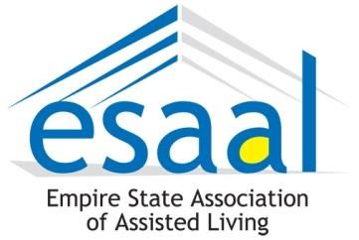

May 10, 2017

***Registration begins at 8:30 a.m.***

**9:30 a.m. – 4:30 p.m.**

NY LaGuardia Airport Marriott, 102-05 Ditmars Blvd., East Elmhurst, NY 11369

ARGENTUM  NEW YORK

EXPANDING SENIOR LIVING



*Improve your facility’s planning for:*

* Incident Response to Cyberattack
* Active Shooter Training
* Psychological First Aid Training

*Updates about these programs:*

* Long Term Care Emergency Management Program
* Long Term Care Exercise Program
* Emergency Radio Communication Program
* Mapping Project

ARGENTUM  NEW YORK

EXPANDING SENIOR LIVING